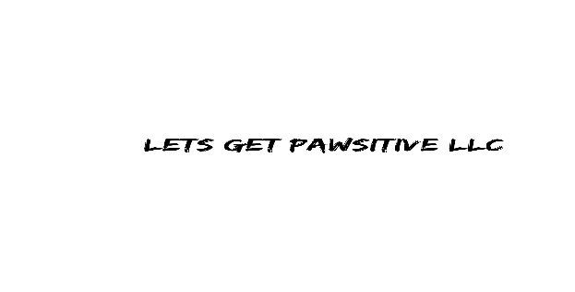

Private Training Service Agreement

I/We _________________________________________________________ (hereinafter referred to as “Client”) have voluntarily

employed LETS GET PAWSITIVE (hereinafter referred to as “Consultant”) to assist me in the training of my dog(s) _________________________________ .

Professional fees:
- Client agrees to pay Trainer a nonrefundable fee in the amount of $________ for first session (approximate length _______ and $_______ for each follow up session (approximate length ________ ).
OR
- Client agrees to pay Trainer a nonrefundable fee in the amount of $________ for a package of _____ sessions (approximate length ________ each) to be paid at first session. All sessions must be completed within 180 days from the date of commencement of contract or they will be forfeited.

“No shows” or cancelled appointments with less than 24 hour notice Client will be billed at ½ of the normal appointment fee.

Description of Service:
I understand that the Consultant will work directly with me and my pet to impart contemporary animal behavior knowledge that best fits our needs, and that successful companion pet programs depend on a combination of learned skills on the part of the pet and the owner. Behavior is not static; an animal will not continue to perform even a trained behavior without ongoing practice. Especially in cases involving any type of aggression, although behavior may be modified, the dog is never considered “cured”. A pet’s behavior is ultimately the owner’s responsibility. Consultant will make every reasonable effort to help us attain goals but makes no guarantees of performance on the part of Client or pet as a result of providing professional animal behavior consultation.

Client acknowledges that obedience training /behavior modification may be an activity in which damage or injury to dog(s) and/or person may occur. Client will assume financial/moral responsibility for the action of their dog(s). Client further

acknowledges that dog(s) may be exposed to a variety of environmental conditions which include, but are not limited to, vehicular travel, interaction with people and other animals, exposure to adverse weather, and exposure to areas with crowds and all types of traffic.

I/We Client agree that I, my heirs, assignees and legal representatives will not make claim against, sue, or attach the property of Consultant, her family, acquaintances, or any other person acting on her behalf (herein referred to as “Her Agents”), for injury or damage done to or by dog(s) resulting from action or negligence, however caused, by Consultant. I/We Client forever release Consultant from any and all liability and demands which I/We Client, and me may have or may hereafter have for injury or damage to or by dog(s), and assume all risks thereof.

Client and Consultant hereby agree to mediate and/or arbitrate any misunderstanding that may arise pursuant to the terms contained herein. In any action or proceeding arising out of this agreement, the prevailing party shall be entitled to reimbursement of cost and legal fees.

Photo and Video Release
I, __________________________________________ (print name), grant permission to LETS GET PAWSITIVE and its legal representatives and assigns, the irrevocable and unrestricted right to use, publish and broadcast my photograph(s), likeness and voice, including via video, for trade, advertising, and any other purpose and in any manner and medium; and to alter the same without restriction. I hereby release LETS GET PAWSITIVE and its legal representatives and assigns from all claims and liability relating to said photograph(s), video(s), likeness and voice.

This Contract for Training Services supersedes all the other agreements, written or oral, previously made between Client and Consultant.

Executed on this _______ day of ___________, 2______

______________________________ ____________________________
“Client” (Print) “Consultant”

_____________________________
(signature)

